**BEST PRACTICE – 2**

**(2023-24)**

**RADIO BROADCASTING: A NOVEL AWARENESS PROGRAM TO IMPROVE COMMUNICATION SKILLS THROUGH MEDIA**

**1. GOAL:** To help students learn about the skills and knowledge needed to produce and broadcast radio programs**.**

**2. THE CONTEXT:** The students were trained to boost their confidence, helping them to overcome public speaking fears and how essential for improving personal and professional growth that could influence their future career choices.

**3. THE PRACTICE:**

1. Around 100 students who were interested to attend the program on RADIO

BROADCASTING to know and get knowledge about the equipment in the radio

station and implement in their daily life to enhance their careers.

b. II Pharmacy students and III Pharm D Students went to Community Radio Station 89.6

MHz Locate in AITS campus.

c. Dr. Kasigari Prasad, Director, Community Radio Station Started the presentation about

its importance and how it enhance the career of students.

d. Students use microphones, audio mixers, recording software, and editing tools.

Familiarity with these tools is crucial, and the program may include training sessions

on their use.

e. The program could broadcast via school radio, online streaming platforms, or

podcasts, allowing students to reach a broader audience.

f. Students need to understand the legal aspects of using music, sound effects, and other

media in their broadcasts. Lessons on copyright and intellectual property are essential.

g. Students improve their verbal and written communication skills, which are essential for

personal and professional growth.

h. Students learn about scriptwriting, interviewing, editing, public speaking, teamwork,

and time management. It also fosters creativity and critical thinking.

i. Segments might include evaluations of new pharmaceuticals, talks about side effects, or

health suggestions for common ailments, all in line with the curriculum's emphasis on

pharmacology and therapeutics.

j. This experience prepares students for roles in pharmaceutical communications, medical

writing, or public health education, offering a broader perspective on career

opportunities in pharmacy.

**1.** **EVIDENCE OF SUCCESS**

Increased student engagement by offering a practical, hands-on learning experience. According to research, students who participate in such programs frequently express enhanced self-confidence, notably in public speaking and presenting complicated concepts, which leads to higher engagement in other academic and extracurricular activities. Pharmacy students with radio broadcasting expertise may pursue careers in pharmaceutical communications, medical writing, or public health advocacy. Case studies and alumni reports frequently reveal that students who participated in these programs went on to have successful careers in fields that required communication and public education.

By implementing & practicing this kind of communication skills related awareness to involve in different modes. The students effectively participated in independence day events such as Elution, Essay writing and won prizes.

**DR.KASIGARI PRASAD, DIRECTOR, STARTED THE PROGRAM IN ANNAMACHARYA INSTITUTE OF TECHNOLOGY & SCIENCES, ANNAMACHARYA TRUST**

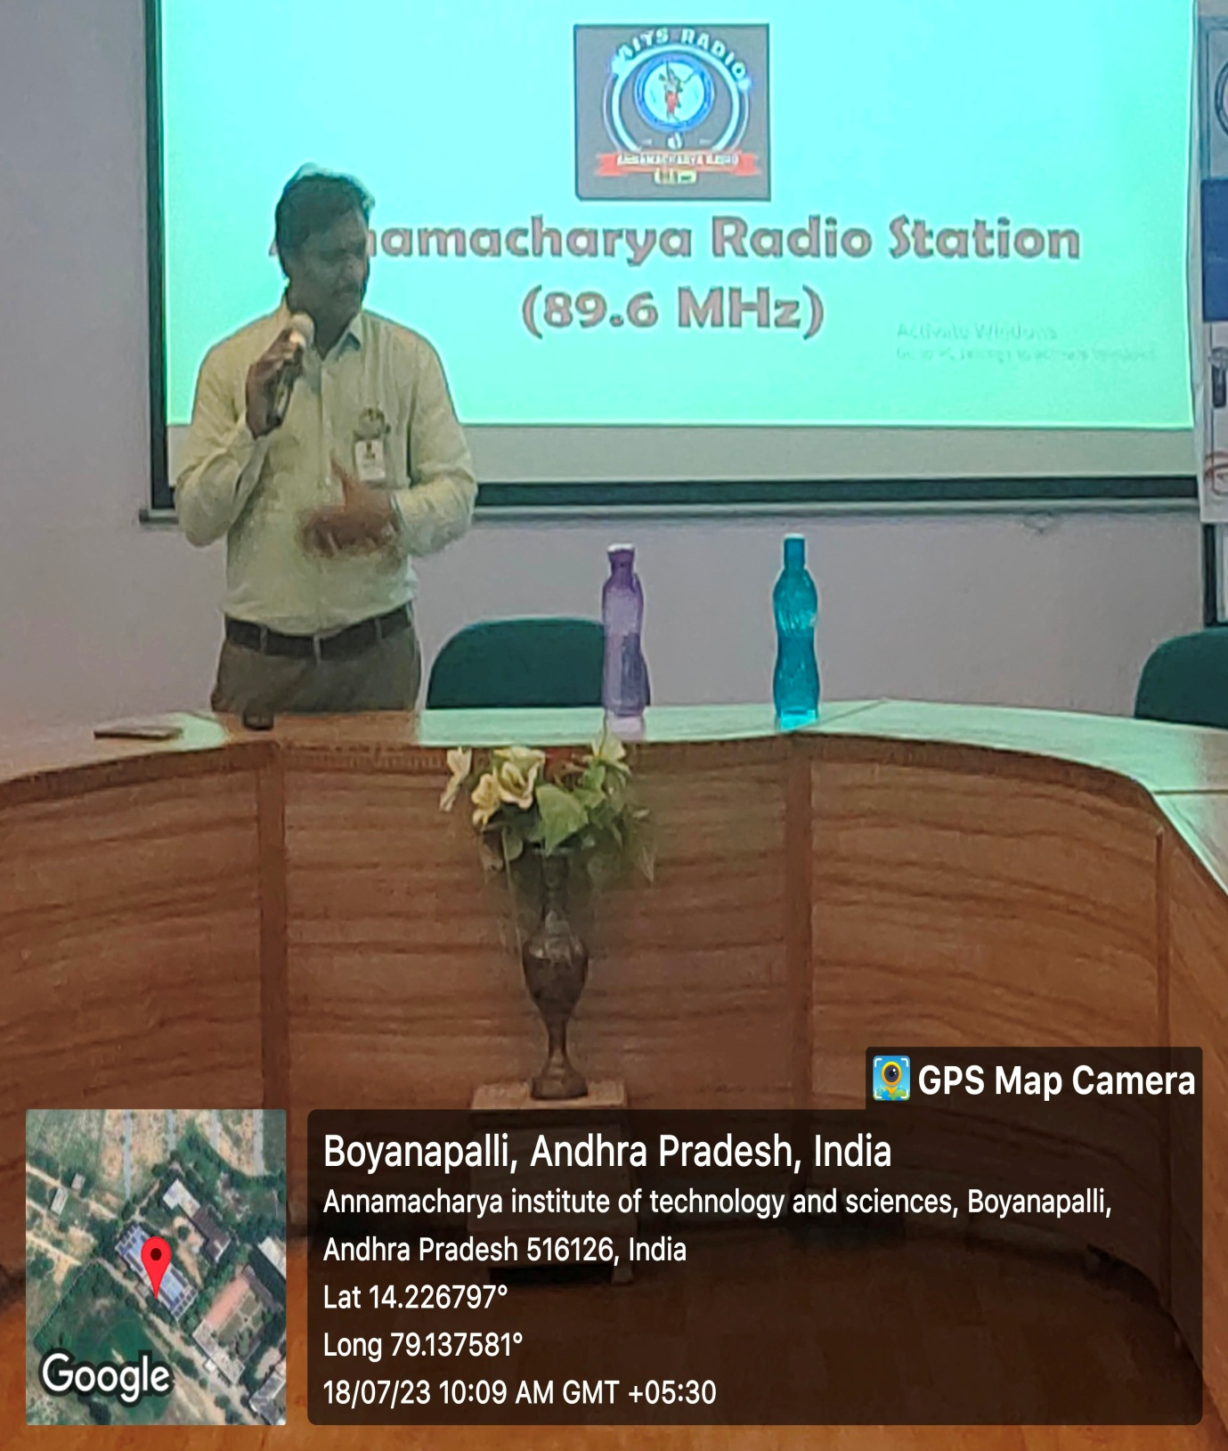

**DELIVERING THE SIGNIFICANCE OF BROADCASTING**

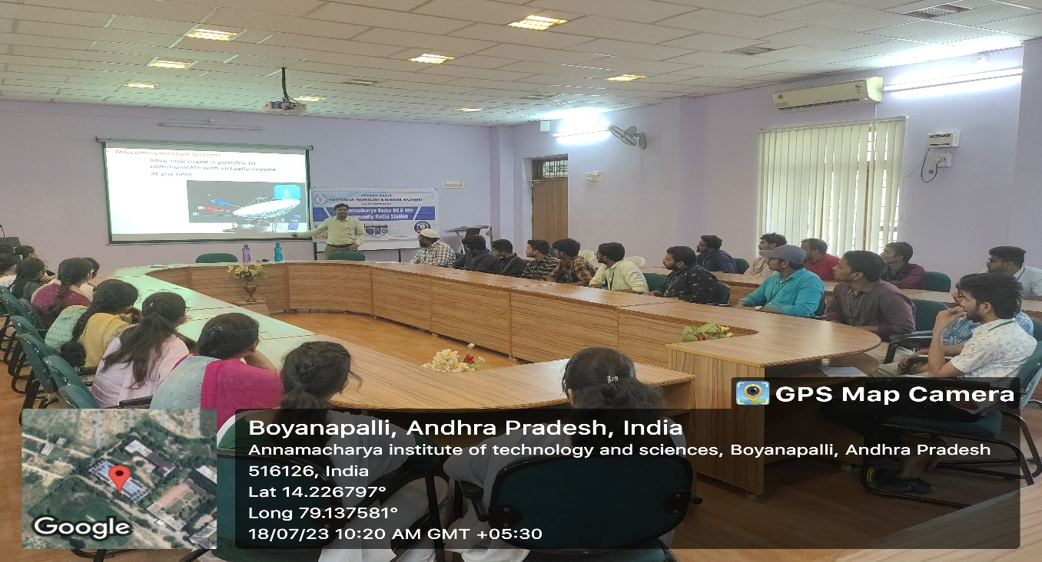

**STUDENTS PARTICIPATED IN THE PROGRAM TO IMPROVE THEIR COMMUNICATION SKILLS IN ANNAMACHARYA INSTITUTE OF TECHNOLOGY & SCIENCES, ANNAMACHARYA TRUST**

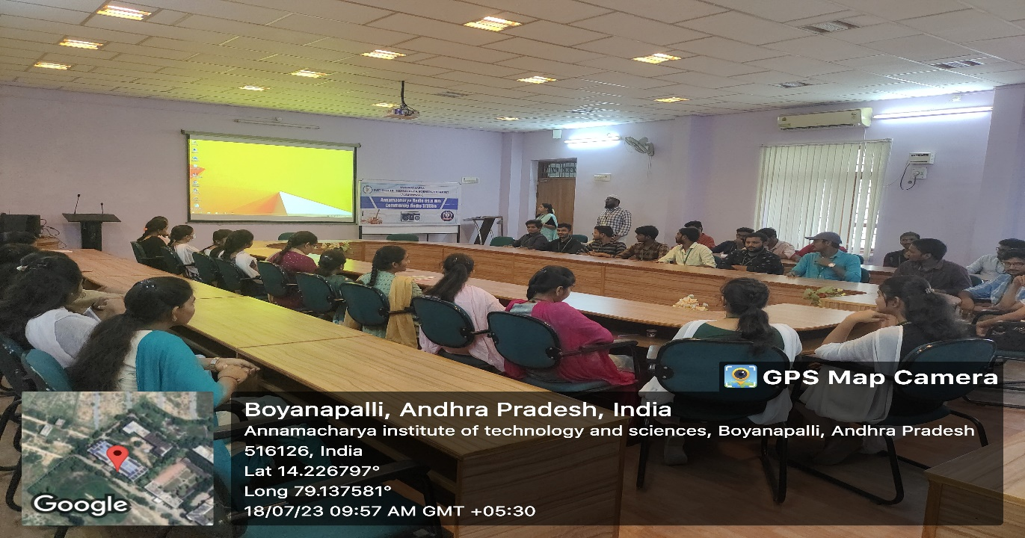

**STUDENTS INTERACTING THROUGH MICROPHONES**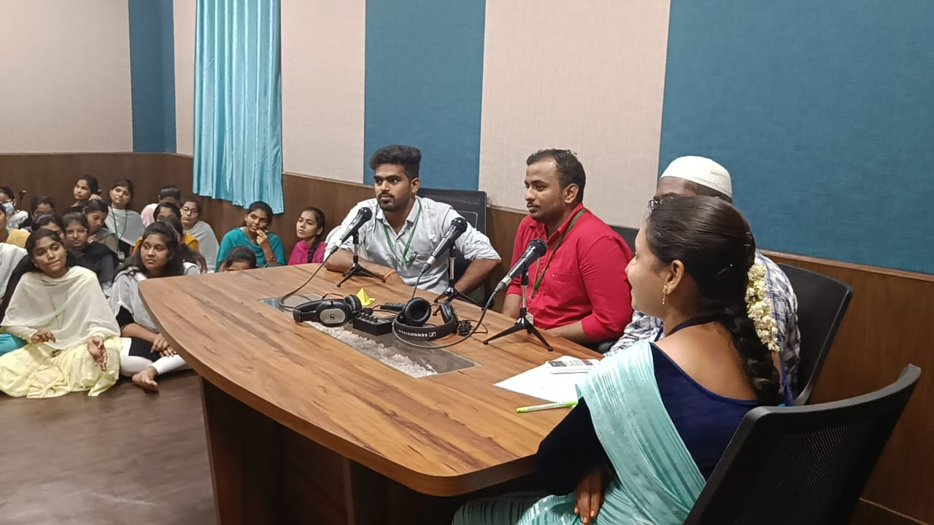

**STUDENTS INTERACTING WITH THE LIDTENERS & DELIVERING MESSAGES**

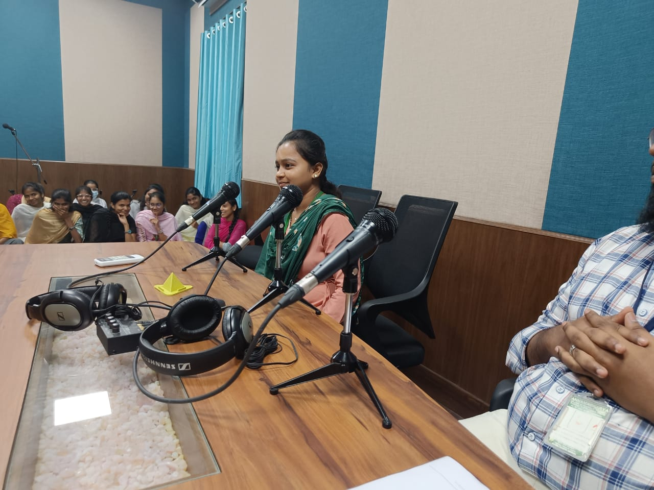

**STUDENTS WON PRIZES FOR BETTER PERFORMANCE IN SPEAKING**

**(ELUTION, ESSAY WRITING)**

